1. **Introduction**
   1. **Purpose**

This document is in order to address the Software Requirements Specification of an Online Accounting Management System.

* 1. **Scope**

Then name of this Online Accounting Management System is MyANT.

Generally, this Online Accounting Management System will let user to create their own accounting plan, process their plan and even collaborate with other user’s plan. Moreover, user can generate the accounting report of their plan.

* 1. **Overview**

This document contains the overall description and the specific requirements which are included in chapter 2 and chapter 3.

1. **Specific Requirements**
   1. **Use Case Diagram**

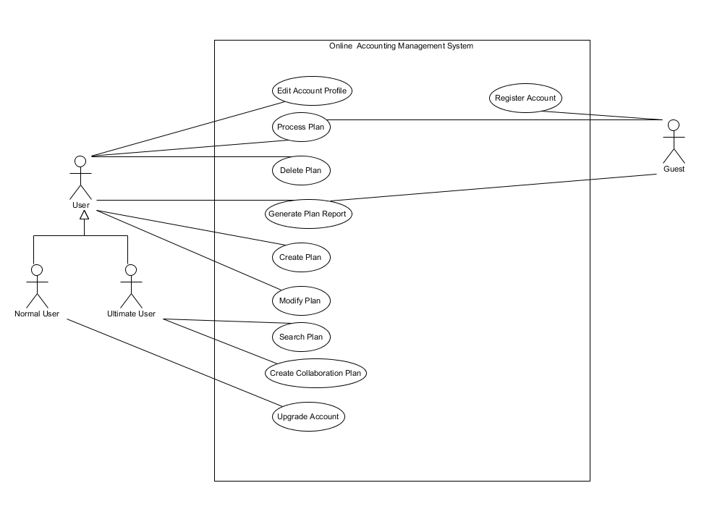

* 1. **Use Case Specifications**

|  |
| --- |
| **Use case: Create Plan** |
| **ID:** UC1 |
| **Actors:**  User, Guest |
| **Preconditions:**  User is in personal page. |
| **Flow of events:**   1. The user click “Create Plan” button on the website. 2. The users insert the plan name in a text field. 3. The user click “Confirm” 4. The system validates the creation request of the plan. 5. If the creation request pass the system validation then    1. The system creates the plan for the user 6. If the creation request does not pass the system validation then    1. The system will inform the user of the creation failed by showing error message. |
| **Post conditions:**   1. The system will show the plan which is created just before immediately |

|  |
| --- |
| **Use case: Process Plan** |
| **ID:** UC2 |
| **Actors:**  User, Guest |
| **Preconditions:**  User is in personal page. |
| **Flow of events:**   1. The user click “plan name”. 2. The system validate the process plan request. 3. If process plan request validation success then    1. The user enter the editing condition.    2. While the user do not click submit button       1. The user is editing the plan.    3. The user click submit button 4. If the process plan request validation failed then    1. The system will inform the user of the process plan failed by showing error message. |
| **Postconditions:**   1. The system show the personal page. |

|  |
| --- |
| **Use case: Delete Plan** |
| **ID:** UC3 |
| **Actors:**  User |
| **Preconditions:**  User has login to the system and is in the personal page. |
| **Flow of events:**   1. User click the “delete” button of a plan. 2. The system validates the delete plan request. 3. If the delete plan request success then    1. The system warnings user by showing caution message and provides “Delete” and “Cancel” button.    2. If user click “Delete” button then       1. The system delete the plan.    3. If user click “Cancel” button.       1. The system cancel the delete request. 4. If the delete plan request failed then 5. The system will inform of the delete plan failed by showing error message. |
| **Postconditions:**   1. The system show the personal page. |

|  |
| --- |
| **Use case: Generate Plan Report** |
| **ID:** UC4 |
| **Actors:**  User, Guest |
| **Preconditions:**  User or Guest already had a plan. |
| **Flow of events:**   1. The user or guest clicks “Generate Report” in personal page or plan process page. 2. System generates plan report. 3. System shows the plan report to users or guest. |
| **Postconditions:**   1. The system stays on the report page and waits for instruction. |

|  |
| --- |
| **Use case: Create Collaboration Plan** |
| **ID:** UC5 |
| **Actors:**  Ultimate User |
| **Preconditions:**  User has login to the system and is in the personal page. |
| **Flow of events:**   1. The ultimate user click “Edit” button of a plan. 2. The system shows the plan profile. 3. The ultimate user click the checkbox of “Change this plan to Collaboration Plan” 4. The system shows Collaboration setting section to ultimate user. 5. The ultimate User input others user’s username or alias. 6. The system searches the username in database. 7. If designed user can not be found in database then    1. The system will inform ultimate user that the user can not be found. 8. If designed user is found in database then    1. The ultimate user clicks designed user name to add it to the collaboration plan.    2. The ultimate user clicks “invite” button.    3. The system sends invitation to the users who are invited to the collaboration plan. |
| **Postconditions:**   1. The system stays on the personal pages. |

|  |
| --- |
| **Use case: Search Plan** |
| **ID:** UC6 |
| **Actors:**  Ultimate User |
| **Preconditions:**  User has login to the system and is in the personal page. |
| **Flow of events:**   1. The ultimate user click “Search” button. 2. The ultimate user input plan name. 3. The system shows the search result. |
| **Postconditions:**   1. The system stays on the personal pages. |

|  |
| --- |
| **Use case: Edit Account Profile** |
| **ID:** UC7 |
| **Actors:**  User |
| **Preconditions:**  User has login to the system and is in the personal page. |
| **Flow of events:**   1. The user clicks “Edit Profile” button. 2. System shows profile page to users. 3. The user changes the content of profile page. 4. The user clicks “Save” button to save the changes. |
| **Postconditions:**   1. The system stays on the personal pages. |

|  |
| --- |
| **Use case: Modify Plan** |
| **ID:** UC8 |
| **Actors:**  User |
| **Preconditions:**  User has login to the system and is in the personal page. |
| **Flow of events:**   1. The user click “Edit” button of a plan. 2. The system shows the plan profile. 3. The user change the plan profile. 4. The user click “Save” button to save the changes. |
| **Postconditions:**   1. The system stays on the personal pages. |

|  |
| --- |
| **Use case: Upgrade Account** |
| **ID:** UC9 |
| **Actors:**  Normal User |
| **Preconditions:**  User has login to the system and is in the personal page. |
| **Flow of events:**   1. The normal user click “Upgrade Account” 2. The normal user input the upgrade key. 3. The normal user click “Upgrade” button. 4. The system validate the account upgrade request. 5. If account upgrade request validation success then    1. The system upgrade the normal user to ultimate user. 6. If account upgrade request validation failed then    1. The system informs user of account upgrade request validation fail. |
| **Postconditions:**   1. The system stays on the personal pages. |

|  |
| --- |
| **Use case: Register Account** |
| **ID:** UC10 |
| **Actors:**  Guest |
| **Preconditions:**   1. The guest is in the welcome page. |
| **Flow of events:**   1. The guest clicks “Sign In” button on the Welcome Page. 2. The guest inputs the login email address. 3. The guest inputs the login password. 4. The system validates the password and email. 5. While the password and email validation failed    1. The system informs guest the password and email validation failed.    2. The guest inputs the login email address.    3. The guest inputs the login password. 6. The system informs guest registration success. 7. The system show the personal profile page. |
| **Postconditions:**   1. The system stays on the personal pages. |

1. **Specification Functional Requirements**
   1. **Guest Requirements**
      1. **Register Account**
         1. The guest shall be able to register normal user account by inputting the valid login email address and password.
         2. The guest shall get the register failed error message when the guest user input the invalid login email address or password.
         3. The guest shall get the register success message when the guest user input he valid long email address and password.
      2. **Create Plan**
         1. The guest shall create one and only one individual accounting plan.
      3. **Process Plan**
         1. The guest shall be able to process the individual accounting plan.
         2. The guest shall add, modify and delete rows in the individual accounting plan.
         3. Each row in the individual accounting plan shall contain “Name”, “Category”, “Price” and “Date”.
      4. **Delete Plan**
         1. The guest shall not be able to delete the individual accounting plan.
      5. **Generate Plan Report**
         1. The guest shall be able to generate the individual accounting plan report.
         2. The individual accounting plan report shall contain purchase amount, category amount between a time period.
      6. **Modify Plan**
         1. The guest shall not be able to modify the plan.
   2. **Normal User Requirements**
      1. **Create Plan**
         1. The normal user shall be able to create no more than 5 individual accounting plan.
         2. The normal user shall not be able to create an individual accounting plan which has the same name with another’s.
      2. **Process Plan**
         1. The normal user shall be able to process the individual accounting plan.
         2. The normal user shall add, modify and delete rows in the individual accounting plan.
         3. Each row in the individual accounting plan shall contain “Name”, “Category”, “Price” and “Date”.
      3. **Delete Plan**
         1. The normal user shall be able to delete the individual accounting plan.
      4. **Modify Plan**
         1. The normal user shall be able to modify the plan profile.
      5. **Generate Plan Report**
         1. The normal user shall be able to generate the individual accounting plan report.
         2. The individual accounting plan report shall contain purchase amount, category amount between a time period.
      6. **Edit Account Profile**
         1. The normal user shall be able to edit his personal account profile.
      7. **Upgrade Account**
         1. The normal user shall upgrade account by entering purchased upgrade key.
   3. **Ultimate User Requirements**
      1. **Create Plan**
         1. The ultimate user shall be able to create no limited amount individual accounting plan.
         2. The ultimate user shall not be able to create an individual accounting plan which has the same name with his other plan.
      2. **Process Plan**
         1. The ultimate user shall be able to process the individual accounting plan and collaboration plan.
         2. The ultimate user shall add, modify and delete rows in the individual accounting plan and collaboration plan.
         3. Each row in the individual accounting plan shall contain “Name”, “Category”, “Price” and “Date”.
         4. Each row in collaboration accounting plan shall contain “Name”, “Category”, “Price”, “Date” and “Purchased By”.
      3. **Delete Plan**
         1. The ultimate user shall be able to delete the individual and collaboration accounting plan.
      4. **Modify Plan**
         1. The ultimate user shall be able to modify the plan profile.
         2. The ultimate user shall be able to specify the collaboration user to join or leave designated collaboration plan.
      5. **Generate plan Report**
         1. The ultimate user shall be able to generate the plan report.
         2. The individual accounting plan report shall contain purchase amount, category amount between a time period.
         3. The collaboration account plan report shall contain purchase amount, category amount and amount of every collaborators between a time period.
      6. **Search Plan**
         1. The ultimate user shall be able to search specific plan by plan name.
      7. **Edit Account Profile**
         1. The ultimate user shall be able to edit his persona account profile.